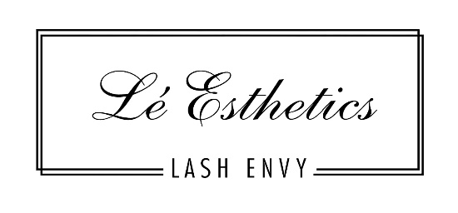

Appointment Terms & Conditions

IMPORTANT INFORMATION: All permanent makeup requires a minimum of two appointments. Your mandatory touch up session will be scheduled within 8-10 weeks of your initial appointment. To ensure that your touch up occurs within the allotted time frame the appointment will be scheduled at the conclusion of your initial appointment. If you miss your scheduled touch up or need to reschedule outside the 8-10-week time frame your new appointment will be subject to additional fees (varies according to artist) -NO EXCEPTIONS
PLEASE NOTE: We provide the same service for every client, but the healed results can vary with every client due to pigment retention. This is dependent on your immune system, skin type, lifestyle, any medications taken, and the before and aftercare instructions. Therefore, healed results are beyond our control.
CHANGING YOUR / TECHNIQUE / COLOR / SHAPE: If you decide to do another technique, change a shape, color, or thickness on your follow up or annual touch up appointment, extra fees will be applied ($200+). Also, an additional follow up touch up appointment ($200) will be required within 8-10 weeks after your appointment to achieve the desired results because this will be the same as doing a new procedure.
PREVIOUS PERMANENT MAKEUP FROM ANOTHER ARTIST / COVERUP CORRECTION: If you had your permanent makeup done by another artist and are interested in a cover-up/correction\rework, YOU MUST FIRST get approval by sending us photos of the existing work. If you fail to do so, we will have the right to refuse or add additional charges to the service on the day of your appointment. As a result, your deposit will be forfeited. Not all previous tattoos from other artists can be fixed or covered.
STUDIO POLICY: No guests, no children, and no pets are allowed in the treatment area/room due to cross-contamination and interruption. Please be respectful and understand that the PMU artist must focus on the permanent tattoo procedure. We also want to ensure the safety of our staff & clients. If you are sick or have any flu-like symptoms, please reschedule your appointment. If you show up to your appointment with any flu, cold, etc. like symptoms, Lé Esthetics has the right to refuse service.
Additional Information:
• No food is permitted inside the treatment area.
• Please set your devices to silent while in the treatment area and take phone calls outside the studio. No cell phone use during the treatment- NO EXCEPTIONS
• Prices are subject to change at the studio’s discretion.
• Lé Esthetics has the right to refuse service to anyone for any reason.
• No Refunds -No exceptions.
DEPOSITS: To book a cosmetic tattoo/removal appointment we require a deposit. All deposits on file will be applied toward your balance on the day of your appointment. All deposits are non-refundable and non-transferable. NO EXCEPTIONS.
PAYMENT: Your balance is due in full on the day of your procedure. We also accept cash and major credit cards as a form(s) of payment. We DO NOT accept personal checks.
RESCHEDULING POLICY: If you need to reschedule your appointment, you may do so by calling, texting or emailing us, any time up to 72 hours (3 days) before your scheduled appointment, otherwise, you will lose your deposit and an additional deposit will be required to make a new appointment reservation. There is NO EXCEPTION, as you can appreciate both your time and our time are very valuable. If you reschedule more than one time, you will need to pay for the entire treatment in advance. Payments are NON-Refundable and NON-TRANSFERABLE -NO EXCEPTIONS.
CANCELLATION POLICY: Same day cancellation and no shows are charged 100% of the scheduled service price. NO EXCEPTIONS. If the card that we have on file for you returns as “Insufficient Funds” we will attempt to process for 30 days. If payment is not secured after 30 days Lé Esthetics reserves the right to pursue legal action at the client’s expense.
LATE POLICY: Please arrive to your appointment on time. If you are more than 15 minutes late, Lé Esthetics reserves the right to cancel your appointment, and your deposit will not be refunded-regardless of unforeseen circumstances that may arise, which could force you to postpone/reschedule your procedure.

